
The Couch by Gordon Blitz
comedy monologue
0 mins
1 male
The Couch Speaks!
More info...

Exploring by Gordon Blitz
drama
10 mins
2 males
Brother-in-laws-in love
More info...
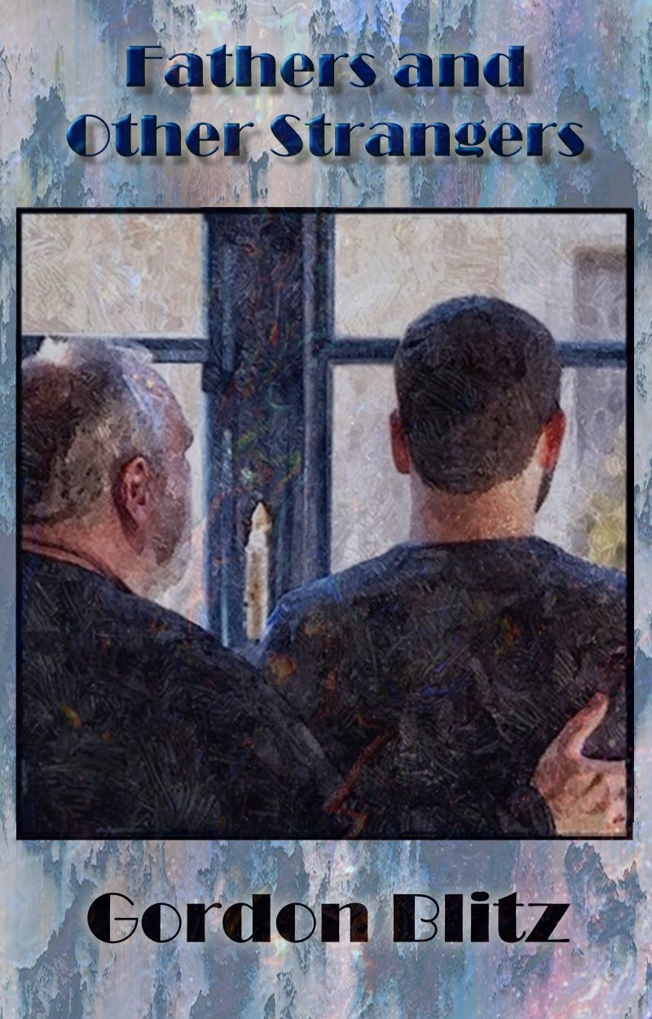
Fathers and Other Strangers by Gordon Blitz
drama
80 - 90 mins
2 females, 3 males
For anyone who has ever imagined creating a truly healing family, this story will inspire you and give you a more clear and satisfying vision.
More info...

Group Sex by Gordon Blitz
drama
9 - 10 mins
5 males
A psychological study of the two gay couples in group therapy attempting to talk about their sex lives.
More info...
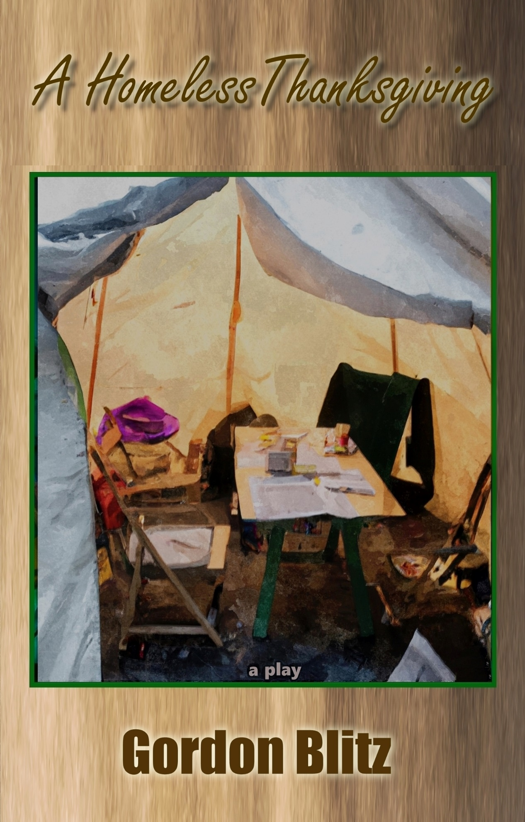
A Homeless Thanksgiving by Gordon Blitz
drama
70 - 80 mins
1 female, 2 males
Three generations of Homeless
More info...

Keep Love In by Gordon Blitz
drama
8 - 10 mins
Has tribalization replaced religion?
More info...

The Massage by Gordon Blitz
drama
10 mins
2 males
The emotional intimacy during a massage
More info...

The Mathematician and The Philosopher by Gordon Blitz
drama
8 - 10 mins
2 males
Strangers in an elevator
More info...

Pablo's Confession by Gordon Blitz
drama
6 - 8 mins
Interfaith, interracial and intergenerational confession
More info...

Reflections by Gordon Blitz
Dark Comedy
45 - 0 mins
1 female, 4 males
Teenage Gay Jewish Boy Converts to Christianity
More info...

Reflections of a Gay Jewish Boy-a ten minute play by Gordon Blitz
drama
10 mins
1 female, 2 males
coming-out saga with a twist
More info...

Reflections of A Teenage Jewish Lesbian by Gordon Blitz
dramedy
80 - 85 mins
3 females, 2 males
Coming out as a lesbian in 1969
More info...

When Love Is Not Enough by Gordon Blitz
drama
70 - 90 mins
When dementia changes who you love.
More info...

7111 Santa Monica Blvd
Suite B-159
West Hollywood, CA 90046
Donate to ALAP Join ALAP

